SEC Form 4

FORM 4

Check this box if no longer subject to Section 16. Form 4 or Form 5 obligations may continue. See Instruction 1(b).

UNITED STATES SECURITIES AND EXCHANGE COMMISSION
Washington, D.C. 20549
 |  | OMB APPROVAL
STATEMENT OF CHANGES IN BENEFICIAL OWNERSHIP
 |  | OMB Number: | 3235-0287
 |  | Estimated average burden
Filed pursuant to Section 16(a) of the Securities Exchange Act of 1934 |  | hours per response: | 0.5
or Section 30(h) of the Investment Company Act of 1940
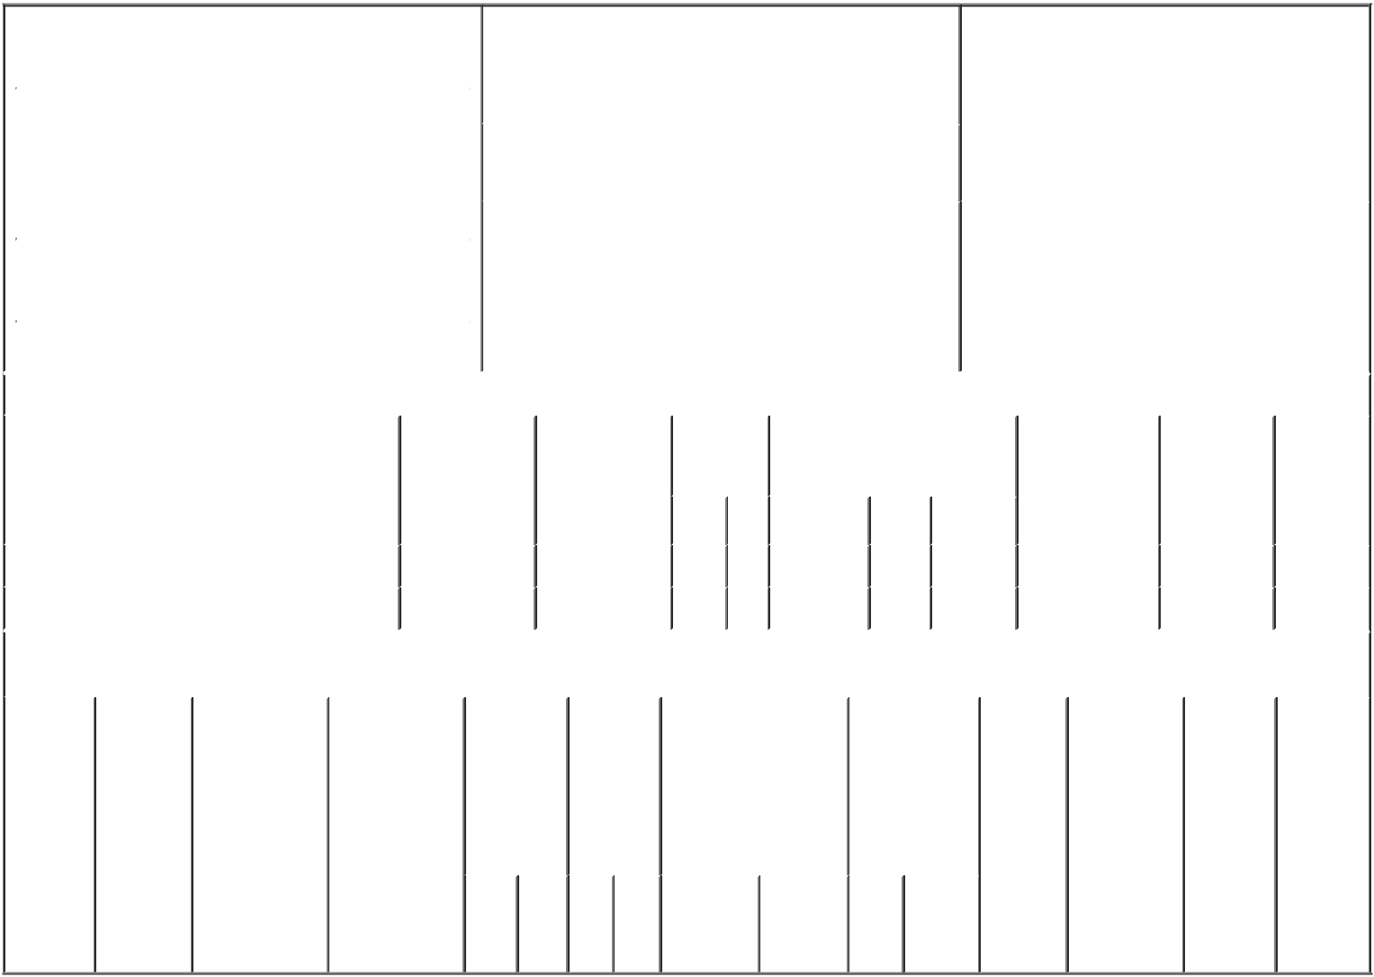

 | 1. Name and Address of Reporting Person* |  |  |  |  |  |  |  |  |  | 2. Issuer Name and Ticker or Trading Symbol |  |  |  |  |  |  |  |  |  |  | 5. Relationship of Reporting Person(s) to Issuer
 |  | Sheresky Michael |  |  |  |  |  |  |  |  | TAKE TWO INTERACTIVE SOFTWARE ^{(Check} ^{all applicable)}
 |  |  |  |  |  |  |  |  |  |  | INC [ TTWO ] |  |  |  |  |  |  |  |  |  |  |  |  | X | Director |  | 10% Owner
 |  |  |  |  |  |  |  |  |  |  |  |  |  |  |  |  |  |  |  |  |  |  |  |  | Officer (give title |  | Other (specify
 |  | (Last) |  | (First) |  |  | (Middle) |  |  |  |  |  |  |  |  |  |  |  |  |  |  |  |  |  | below) |  | below)
 |  | C/O TAKE-TWO INTERACTIVE SOFTWARE, |  |  |  |  |  |  |  |  | 3. Date of Earliest Transaction (Month/Day/Year)
 |  | INC. |  |  |  |  |  |  | 08/10/2018
 |  | 110 WEST 44TH STREET
 |  |  |  |  |  |  |  |  |  |  | 4. If Amendment, Date of Original Filed (Month/Day/Year) |  |  |  |  |  |  |  |  |  |  | 6. Individual or Joint/Group Filing (Check Applicable
 |  |  |  |  |  |  |  |  |  |  |  |  |  |  |  |  |  |  |  |  |  | Line)
 | (Street) |  |  |  |  |  |  |  |  |  |  |  |  |  |  |  |  |  |  |  |  |  |  | X Form filed by One Reporting Person
 |  | NEW YORK |  | NY |  |  | 10036 |  |  |  |  |  |  |  |  |  |  |  |  |  |  |  |  |  | Form filed by More than One Reporting
 |  |  |  |  |  |  |  |  |  |  |  |  |  |  |  |  |  |  |  |  |  |  |  |  | Person
 |  | (City) |  | (State) |  |  | (Zip)
 |  |  |  |  |  | Table I - Non-Derivative Securities Acquired, Disposed of, or Beneficially Owned
 | 1. Title of Security (Instr. 3) |  |  |  |  |  | 2. Transaction |  |  |  |  |  | 2A. Deemed |  | 3. |  | 4. Securities Acquired (A) or |  |  |  |  |  |  |  | 5. Amount of |  | 6. Ownership | 7. Nature
 |  |  |  |  |  |  | Date |  |  |  |  |  | Execution Date, |  |  | Transaction | Disposed Of (D) (Instr. 3, 4 and 5) Securities |  |  |  |  |  |  |  |  |  | Form: Direct | of Indirect
 |  |  |  |  |  |  | (Month/Day/Year) |  |  |  |  |  | if any |  |  | Code (Instr. |  |  |  |  |  |  |  |  | Beneficially |  | (D) or Indirect | Beneficial
 |  |  |  |  |  |  |  |  |  |  |  |  | (Month/Day/Year) |  | 8) |  |  |  |  |  |  |  |  |  | Owned Following |  | (I) (Instr. 4) | Ownership
 |  |  |  |  |  |  |  |  |  |  |  |  |  |  |  |  |  |  |  |  |  |  |  |  | Reported |  |  | (Instr. 4)
 |  |  |  |  |  |  |  |  |  |  |  |  |  |  |  | Code V | Amount | (A) or |  | Price |  |  |  |  | Transaction(s)
 |  |  |  |  |  |  |  |  |  |  |  |  |  |  |  |  |  | (D) |  |  |  |  |  |  | (Instr. 3 and 4)
 | Common Stock |  |  |  |  |  | 08/10/2018 |  |  |  |  |  |  |  |  | A | 451⁽¹⁾ | A |  | $0 |  |  |  |  |  | 69,168 | D
 | Common Stock |  |  |  |  |  | 08/13/2018 |  |  |  |  |  |  |  |  | S | 295⁽²⁾ | D |  | $129.07 |  |  |  |  |  | 68,873 | D
 |  |  |  |  |  | Table II - Derivative Securities Acquired, Disposed of, or Beneficially Owned
 |  |  |  |  |  |  | (e.g., puts, calls, warrants, options, convertible securities)
 | 1. Title of |  | 2. |  | 3. Transaction |  | 3A. Deemed |  | 4. |  |  |  |  | 5. Number | 6. Date Exercisable and |  |  | 7. Title and |  |  |  |  |  | 8. Price of |  | 9. Number of | 10. | 11. Nature
 | Derivative |  | Conversion |  | Date |  | Execution Date, |  | Transaction |  |  |  |  | of | Expiration Date |  |  | Amount of |  |  |  |  |  | Derivative |  | derivative | Ownership | of Indirect
 | Security |  | or Exercise |  | (Month/Day/Year) |  | if any |  | Code (Instr. |  |  |  |  | Derivative | (Month/Day/Year) |  |  | Securities |  |  |  |  |  | Security |  | Securities | Form: | Beneficial
 | (Instr. 3) |  | Price of |  |  |  | (Month/Day/Year) |  | 8) |  |  |  |  | Securities |  |  |  | Underlying |  |  |  |  |  | (Instr. 5) |  | Beneficially | Direct (D) | Ownership
 |  |  | Derivative |  |  |  |  |  |  |  |  |  |  | Acquired |  |  |  | Derivative |  |  |  |  |  |  |  | Owned | or Indirect | (Instr. 4)
 |  |  | Security |  |  |  |  |  |  |  |  |  |  | (A) or |  |  |  | Security (Instr. 3 |  |  |  |  |  |  |  | Following | (I) (Instr. 4)
 |  |  |  |  |  |  |  |  |  |  |  |  |  | Disposed |  |  |  | and 4) |  |  |  |  |  |  |  | Reported
 |  |  |  |  |  |  |  |  |  |  |  |  |  | of (D) |  |  |  |  |  |  |  |  |  |  |  | Transaction(s)
 |  |  |  |  |  |  |  |  |  |  |  |  |  | (Instr. 3, 4 |  |  |  |  |  |  |  |  |  |  |  | (Instr. 4)
 |  |  |  |  |  |  |  |  |  |  |  |  |  | and 5)
 |  |  |  |  |  |  |  |  |  |  |  |  |  |  |  |  |  |  | Amount
 |  |  |  |  |  |  |  |  |  |  |  |  |  |  |  |  |  |  | or
 |  |  |  |  |  |  |  |  |  |  |  |  |  |  |  |  |  |  | Number
 |  |  |  |  |  |  |  |  |  |  |  |  |  |  | Date |  | Expiration |  | of
 |  |  |  |  |  |  |  |  | Code V |  |  |  |  | (A) (D) | Exercisable |  | Date | Title | Shares

Explanation of Responses:

- Represents the acquisition of shares pursuant to a grant of restricted common stock pursuant to the Director compensation program (the "Program") and the Issuer's 2017 Stock Incentive Plan (the "Stock Plan"). The shares of restricted stock vest on the first anniversary of the Pricing Date (as defined below). As provided by the terms of the Program and the Stock Plan, (i) the grant date was August 10, 2018; and (ii) the number of shares were determined based on the dollar value of the award and the average of the closing prices of the common stock on the ten trading days prior to August 10, 2018 (the "Pricing Date"), the fifth trading day following the filing of the Issuer's Quarterly Report on Form 10-Q.

- This transaction was effected pursuant to a Rule 10b5-1 trading plan entered into by the Reporting Person and was effected to satisfy the Reporting Person's tax obligations upon the vesting of previously granted shares of restricted stock.

/s/ Michael Sheresky |  | 08/14/2018
** Signature of Reporting Person |  | Date

Reminder: Report on a separate line for each class of securities beneficially owned directly or indirectly.

* If the form is filed by more than one reporting person, see Instruction 4 (b)(v).

- Intentional misstatements or omissions of facts constitute Federal Criminal Violations See 18 U.S.C. 1001 and 15 U.S.C. 78ff(a). Note: File three copies of this Form, one of which must be manually signed. If space is insufficient, see Instruction 6 for procedure.
Persons who respond to the collection of information contained in this form are not required to respond unless the form displays a currently valid OMB Number.

