UNITED STATES

SECURITIES AND EXCHANGE COMMISSION
Washington, D.C. 20549

SCHEDULE 14A

Proxy Statement Pursuant to Section 14(a) of the

Securities Exchange Act of 1934
(Amendment No. )

Filed by the Registrant ☒ Filed by a Party other than the Registrant ☐

Check the appropriate box:

- Preliminary Proxy Statement

- Confidential, for Use of the Commission Only (as permitted by Rule 14a-6(e)(2))

- Definitive Proxy Statement

- Definitive Additional Materials

- Soliciting Material Pursuant to §240.14a-12

Take-Two Interactive Software, Inc.

(Name of Registrant as Specified In Its Charter)

(Name of Person(s) Filing Proxy Statement, if other than the Registrant)

Payment of Filing Fee (Check the appropriate box):

- No fee required.

- Fee computed on table below per Exchange Act Rules 14a-6(i)(1) and 0-11.

  - Title of each class of securities to which transaction applies:

  - Aggregate number of securities to which transaction applies:

  - Per unit price or other underlying value of transaction computed pursuant to Exchange Act Rule 0-11 (set forth the amount on which the filing fee is calculated and state how it was determined):

  - Proposed maximum aggregate value of transaction:

  - Total fee paid:

- Fee paid previously with preliminary materials.

- Check box if any part of the fee is offset as provided by Exchange Act Rule 0-11(a)(2) and identify the filing for which the offsetting fee was paid previously. Identify the previous filing by registration statement number, or the Form or Schedule and the date of its filing.

  - Amount Previously Paid:

  - Form, Schedule or Registration Statement No.:

  - Filing Party:

  - Date Filed:

Persons who are to respond to the collection of information contained in this form are not required to respond unless the form displays a currently valid OMB control number.


Your Vote Counts!

TAKE-TWO INTERACTIVE SOFTWARE, INC.

2021 Annual Meeting

Vote by September 13, 2021

11:59 PM ET



D57918-P59608


You invested in TAKE-TWO INTERACTIVE SOFTWARE, INC. and it’s time to vote!

You have the right to vote on proposals being presented at the Annual Meeting. This is an important notice regarding the availability of proxy material for the shareholder meeting to be held on September 14, 2021.

Get informed before you vote

View the Notice and Proxy Statement and Annual Report online OR you can receive a free paper or email copy of the material(s) by requesting prior to August 31, 2021. If you would like to request a copy of the material(s) for this and/or future shareholder meetings, you may (1) visit www.ProxyVote.com, (2) call 1-800-579-1639 or (3) send an email to sendmaterial@proxyvote.com. If sending an email, please include your control number (indicated below) in the subject line. Unless requested, you will not otherwise receive a paper or email copy.
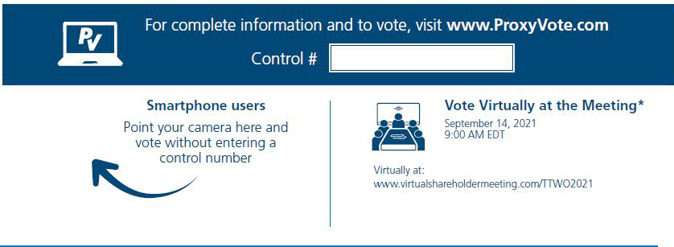

* Please check the meeting materials for any special requirements for meeting attendance.

V1

Vote at www.ProxyVote.com

THIS IS NOT A VOTABLE BALLOT

This is an overview of the proposals being presented at the upcoming shareholder meeting. Please follow the instructions on the reverse side to vote these important matters.

Voting Items

Board
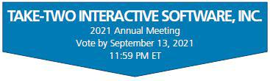

Recommends

1. | Election of Directors
 | Nominees:
1a. | Strauss Zelnick |  | For
1b. | Michael Dornemann |  | For
1c. | J. Moses |  | For
1d. | Michael Sheresky |  | For
1e. | LaVerne Srinivasan |  | For
1f. | Susan Tolson |  | For
1g. | Paul Viera |  | For
1h. | Roland Hernandez |  | For
2. | Approval, on a non-binding advisory basis, of the compensation of the Company’s “named executive officers” as disclosed in |  | For
 | the Proxy Statement. |  | For
3. | Approval of the amendment to the Amended and Restated Take-Two Interactive Software, Inc. 2017 Stock Incentive Plan. |  | For
4. | Ratification of the appointment of Ernst & Young LLP as our independent registered public accounting firm for the fiscal year |  | For
 | ending March 31, 2022. |  | For
NOTE: Such other business as may properly come before the meeting or any adjournment thereof.

D57919-P59608

